1) Escreva palavras derivadas dos substantivos a seguir terminadas em **ISAR** ou **IZAR.**



Revisão:______________________________________

Análise:______________________________________

Útil:_________________________________________

Improviso:____________________________________

Catequese:___________________________________

Aviso:_______________________________________

Liso:________________________________________

Concreto:____________________________________

Sintonia:_____________________________________

2) Escreva as palavras primitivas que correspondem aos verbos a seguir e, depois localize-as no caça-palavras.

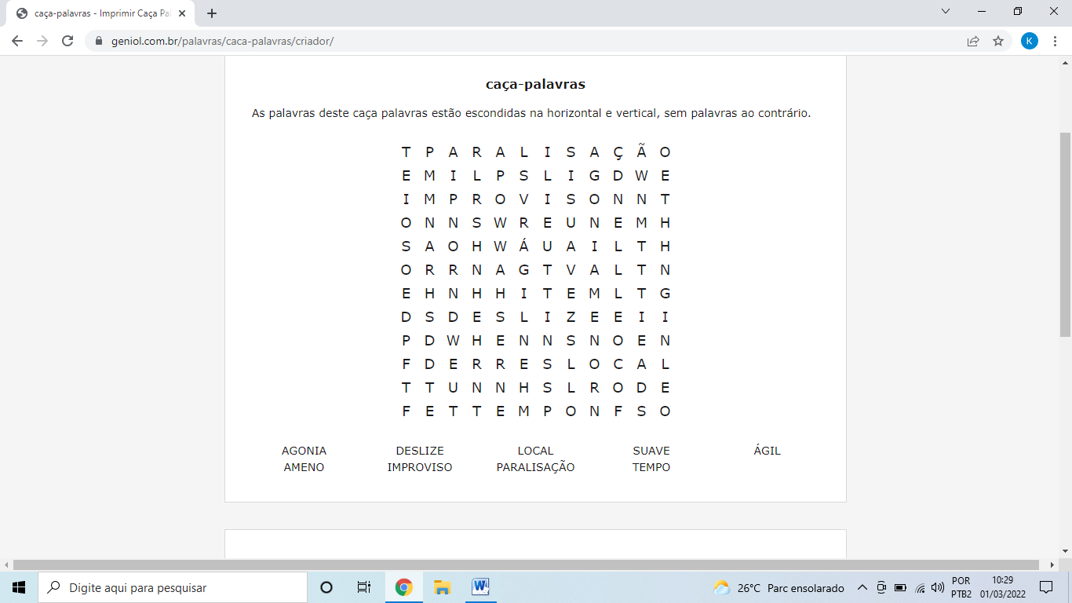

Amenizar:__________________________________

Deslizar:____________________________________

Agonizar:___________________________________

Localizar:___________________________________

Agilizar:___________________________________

Paralisar:___________________________________

Suavizar:____________________________________

Improvisar:__________________________________

Temporizar:__________________________________